
Technical Submittal – R03
Dec 2020
Prepared for Endress + Hauser, Waluj Aurangabad

Scissor Lift, Motorized Retractable gate, Manual Wicket Gate, Double Sided Flap Gate:

Contactor Name:
Shubhshree Engineering and Constructions Pvt Ltd
401-404, Sai Business centre, Osmanpura
Aurangabad-431005, MH, India.

Supplied Name: NIHVA Technologies Pvt Ltd

Prepared by,
Shubhshree Engineering and Constructions Pvt Ltd
401-404, Sai Business centre, Osmanpura
Aurangabad-431005, MH, India.

Table of Contents

- Introduction
- Product Sample Photo
- Scope of Supply
- BOQ & Compliance
- GA Drawing
- Technical submittals
- Factory sample test reports
- Optional Items & Deviation List

- Introduction

NIHVA Technologies Pvt Ltd, Pune

NIHVA’s Head Office & manufacturing facility is located in Pune in Maharashtra (India) & sales office at various metro cities.
NIHVA is young and growing company, having experience of 7 years in industrial market. NIHVA specializes in providing integrated solutions in Door Automation & Automation Solutions.
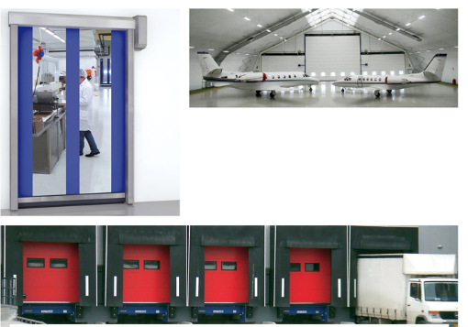

Apart from this NIHVA is also equipped in providing water management and drainage solutions (external and internal).

- Product Sample Photos

Scissor Lift
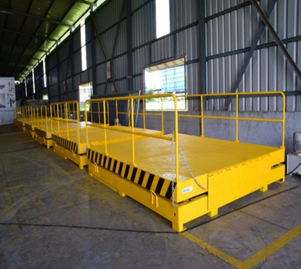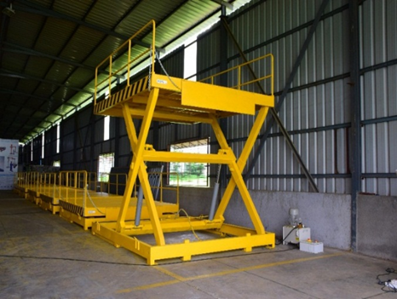

Motorised two leaf Telescopic Gate
Manual Wicket Gate

Double Sided Flap Gate:

- Scope of Supply
Sr. N | Products | Size | Qty | Remark
1 | Hot Dip Galvanized Scissor Lift | (W) 2000 mm X (L) 2500 mm | 4 | Size As per BOQ
2 | Retractable Dock Shelter | (W) 3450 mm X (L) 3400 mm | 4 | Size As per BOQ
3 | Rolling Shutter | (W) 2500 mm X (L) 4000 mm  (W) 4000 mm X (L) 4000 mm | 4  8 | Size As per BOQ  Size As per BOQ
4 | Telescopic Sliding Gate | (W) 6000 mm X (L) 1800 mm | 1 | Size of gate to be conform
5 | Wicket Gate | (W) 1200 mm X (L) 1800 mm | 1 | Size of gate to be conform
6 | Double leaf SS Flap Barrier Gate | 1400 x 280 x 980 mm | 1 | Size of gate to be conform

- BOQ & Compliance

- GA Drawing

Actual GA Drawing shall be provide after confirmation of PO

Scissor Lift GA Drawing Option - 1
We suggest to keep on ground as it will not give mobile movement and will be stationary which will increase the life of Scissor lift.

Scissor Lift GA Drawing Option - 2

Telescopic Sliding Gate

- Technical submittals

Scissor Lift:
Sr. NO | Description | Specification
1 | Capacity | 6 Ton (UDL)
2 | Platform Size | (W) 2000 mm X (L) 2500 mm
3 | Shut Ht | 1000 mm
4 | Max Ht | 2200 mm
5 | Lift Ht | 1200 mm
6 | Safety Railing | Safety railing M.S SECTION 900 mm Ht on length side on platform & Detachable.
7 | Manual Lip | 3 Piece (300 + 1400 + 300) - 1 Side Only
8 | Maintenance Stopper | 2 NOS
9 | Push Button Pendent | Flexible pendent with 5 Mtr Cable - 1 No
10 | Control Panel | Outside pit - 1 No
11 | Safety Bellow | All side
12 | Power Pack Inside Pit with Buzzer | Compact, 15 HP, 3 Phase - Eaton make
13 | Hydraulic Cylinder | Two numbers with Bore 150 X stroke 500 mm - Eaton make
14 | Hot Dip Galvanized | IS 2629 / EN ISO 1461 / As per ASTM
15 | Hose | Parker Hoses
16 | Cable | 5mtr pendant Polycab cable as per site requirement.
17 | Hydraulic Oil | Servo-Grade 68 - 125
18 | Safety Edge | On All sides
19 | Fabrication | 3500KG
20 | Pit | Pit size will be confirmed along with GA.

Sliding Gate:

Sr. No | Description | Specification
1 | Door type | Motorized Two Leaf Telescopic Sliding Gate
2 | Size considered | Clear opening - (W) 6000 mm x (H)1800 mm
3 | Opening Direction | Horizontal - from left to right or reverse
4 | Mounting Location area | Inside area
5 | Design Pattern | Standard Tubular Design Pattern
6 | Outer Frame Tube Sizes | 80 x 80 x 3.2 mm
7 | Internal Vertical Tube Sizes | 40 x 40 x 2 mm
8 | Gap Between Tubes | 100 mm C/C
9 | Bottom Rail on ground | dia 20 mm round bright bar with heavy duty support ISMB 100 X 50 Beams
10 | Bottom Rollers | Heavy Duty Bottom Wheel With both side Bearings (chrome plated)
11 | Guide Rollers supporter during Gate movement | Nylon Rollers with Bearings both side mounted on column for support smooth movement of gate
12 | Painting | Surface preparation before painting as per IS Code. Epoxy paint with zinc enriched epoxy primer
13 | El motor make | BFT – Italy (100% imported)- IP 54 -Single phase ( 230V ) , Motor Date sheet will be provided after Purchase order .
14 | Operating Station. | Push Button from inside with two NO and One NC. Reverse and forward with emergency stop. Location will be Security Cabin.
15 | Operation | By Telescopic Mechanism
16 | Safety | Photocells, Flashing Light. Photocell Data sheet will be provided after Purchase order.

Wicket Gate:

Sr. No | Description | Specification
1 | Door type | Manual Single Leaf Wicket Gate
2 | Size considered | Clear opening - (W)1200 mm x (H)1800 mm
3 | Mounting Location area | Inside area
4 | Design Pattern | Standard Tubular Design Pattern
5 | Outer Frame Tube Sizes | 80 x 80 x 3.2 mm
6 | Internal Vertical Tube Sizes | 40 x 40 x 2 mm
7 | Gap Between Tubes | 100 mm C/C
8 | Painting | Surface preparation before painting as pe IS Code. Epoxy paint with zinc enriched epoxy primer
9 | Operation | Manually Opening
10 | Locking Arrangement. | MS Heavy Duty Bolt Sliding Door Latches Lock.

Double Leaf SS Flap Barrier Gate:

Sr. No | Description
1 | It has zero position of self -checking, easy for users to maintain and use.
2 | There is alarm notice function when illegal access.
3 | Avoid bump function: When the turnstile does not receive the open signals, the baffle will lock automatically.
4 | IR/mechanical dual anti-lined function: When the baffle has problem in reseeding, it will stop working automatically in certain time, and the potency is small, will make an alarm sound at the same time.
5 | Resent automatically: the passenger read effectively, the system will cancel this access authority if they will not access in certain time.
6 | Standard wiring connection: can connect with many kinds of card readers, and can remote control through the computer.
7 | High throughput, Bi-directional control, Open / Close light indication
8 | Optical beams for safety movements, Ensures rapid, efficient & safe access control
9 | Easily integrated into access control system, Automatic reset of barrier flap after each valid entry, mechanical release key for emergency cases, fire trigger input facility. In the event of power failure panels can be specified to remain closed
10 | The whole system works steadily, and the noise is very low. Size: 1400 x 280 x 980mm; Unlock time: 0.2s Pass rate: 35 person/min; Pass Width: ≤550mm; Input:  100V~240V; Driving Voltage: 24v; Environment: -25~70°c; Power Consumption: 35w; Input: 12v dry contact.

- Factory Sample Test Report

Shall be provided along with Product

- Optional Items & Deviation List

S. N | Description | Remarks
1 | NIHVA Hot Dip Galvanized Scissor Lift  (W) 2000 mm X (L) 2500 mm | Complied With BOQ
3 | Any civil / masonry/structural work required | Not in Scope
4 | All structure support | Shall be provided with additional cost.
5 | In Case of any changes in the layout as per site requirements after the shipment of material, the additional quantities and the wastage. | Not in Scope
6 | Conduits, Cables required | Not in Scope
7 | Safety Railings in Scissor Lift | Along Length sides only

SR NO | Product | Remarks
8 | Flap Barrier | Required in SS material
8 | Flap Barrier | Double leaf Type
8 | Flap Barrier | Need to be integrated with clients RFID card
8 | Flap Barrier | Client will provide RFID tag with receiver
8 | Flap Barrier | Detail Technical specs to be provided by client (BOQ)
9 | Sliding Gate | Client has considered rectrable sliding gate but after detailed technical discussion NIHVA has proposed Telescopic Sliding Gate
9 | Sliding Gate | Sliding gate needs to Hot dip galvanized
9 | Sliding Gate | Client will provide detail dimension along with single leaf or double leaft type & required accessories
9 | Sliding Gate | Make: NIHVA
 |  |  |  | Hot Dip Galvanized
12 | Scissor Lift | All platform four edges should have safety edge
12 | Scissor Lift | Safety Below need to be consider
12 | Scissor Lift | Interlock with Dock Leveler & Sectional Door
12 | Scissor Lift | Make : NIHVA
12 | Scissor Lift | Make : NIHVA
 | Product | Make as per BOQ | Revised make
13.1 | Scissor Lift | NIHVA make | Revised: Safety Edge & bellows added
13.3 | Motorised Rolling Shutter | Make: NIHVA  Single skinned GI Rolling Shutter  Profile - Curved  Indirect Drive Motor : PRC Make | Make: Option 1 : NIHVA  Single skinned Galvalume Rolling Shutter  Direct Drive Motor : German Make  Profile: Flat

Minutes of Meeting Discussion point during TDS Review with Client and CBRE on 09/12/2020

